13. Scenario: You are working on a text analysis project and need to determine the frequency

distribution of words in a given text document. You have a text document named "sample_text.txt"

containing a paragraph of text. Your task is to develop a Python program that reads the text

document, processes the text, and generates a frequency distribution of the words.

Question: How would you develop a Python program to calculate the frequency distribution of

words in a text document?

**Code:**

import pandas as pd

import matplotlib.pyplot as plt

df = pd.read_csv(r"C:\Users\jampa\Downloads\word_frequency_distribution.csv")

df_sorted = df.sort_values(by='Frequency', ascending=False)

top_words = df_sorted.head(20)

plt.figure(figsize=(12, 6))

plt.bar(top_words['Word'], top_words['Frequency'], color='skyblue')

plt.xlabel('Words')

plt.ylabel('Frequency')

plt.title('Top 20 Word Frequency Distribution')

plt.xticks(rotation=45)

plt.tight_layout()

plt.show()

**output:**

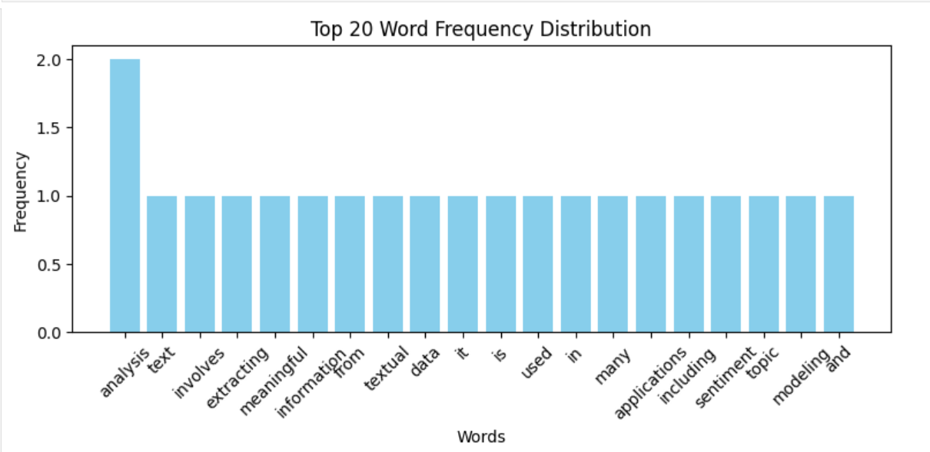

**Dataset:**

|  |  |
| --- | --- |
| Word | Frequency |
| text | 1 |
| analysis | 2 |
| involves | 1 |
| extracting | 1 |
| meaningful | 1 |
| information | 1 |
| from | 1 |
| textual | 1 |
| data | 1 |
| it | 1 |
| is | 1 |
| used | 1 |
| in | 1 |
| many | 1 |
| applications | 1 |
| including | 1 |
| sentiment | 1 |
| topic | 1 |
| modeling | 1 |
| and | 1 |
| keyword | 1 |
| extraction | 1 |